Human Population Growth Lab
Students’ Name
Institution of Affiliation

Answer to Question 1
The publisher of the website is world bureau of statistics in World wide. It is mainly funded by the United States Wolrdometers firm in the world which mainly collect fund from the federal government in America.
Answer to Question 2
Recent world population estimate as taken by the United Nation’s Worldometers at June this year is 7.7 billion. The source of the estimate is the collected and recorded data under the Bereau world population estimate under Worldometers.
Answer to Question 3
The rate of natural increase refers to the difference that exists between the crude rate of death and crude rates of birth in the world. It is mainly obtained through subtracting the mentioned birth rate from the death rate in order to attain the estimate for the world’s population.
Answer to Question 4
- The current rate of growth in the world is approximated to be 82 million in each year. According to worldometers, the percentage rate of growth is approximated to be about 1.07%.
- In reference to calculation of the time taken for the population to double, it is clear that it is obtained through the formula below
70/ percentage growth rate
Therefore, Time taken for the current population to double will be
70/ 1.07%= (70 X100)/ 1.07
Getting rid of the decimal point, we will have
{(70 X 100) X 100}/ 107 = 700000/107 = 6542.05years. Basing argument on the fact that years are not expressed in decimal form, then the number of years for the population to double is 6543years.
- Regardless of the fact that the world population is growing exponentially, it is important noting that the population will double in the span of period calculated above as the change is proportionate in all aspects.
Answer to Question 5
The three countries with high value of rates of natural increase include Niger with the highest rate, followed by Uganda and third ranked country is Timor leste. Looking at the countries mentioned, research depicts that their economy is highly affected by the high rates of natural increase.
Answer to Question 6
- Region with low rates of the natural increase are specific regions with high level of net out-immigration rates.
- Medium rates of natural resources are experienced in regions with almost equal values of the net in-immigration and net out-immigration rates.
- High rates are mainly with regions experiencing high level of net in-immigration rates.
Answer to Question 7
- In the year 2014, the most populous country was China with 1.40 billion of the people.
- By 2050, it is assumed that the most populous country will be India due to an increased fertility rate of the Indian regions.
Answer to Question 8
As predicted in the year 2014, the rank of US was moderate. However, by the year 20150, it is predicted that its rank will be amongst the high populous regions.
Answer to Question 9
- Developing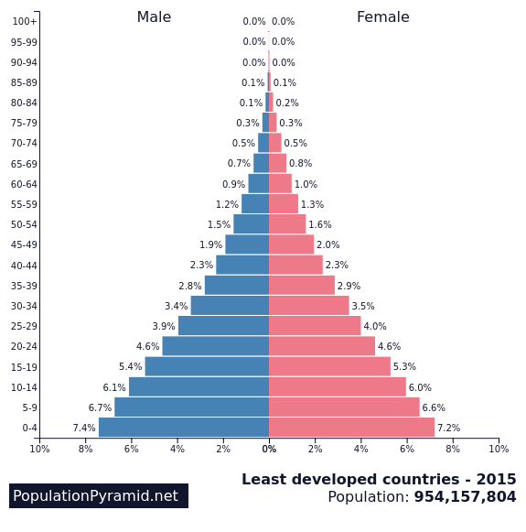
Developed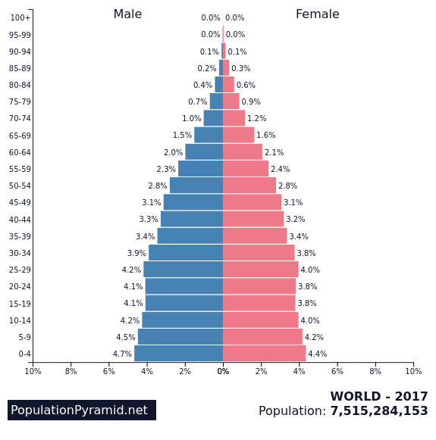
- In most developing countries, youths and children or the young represent the majority of the population because of high birth rates.
Answer to Question 10
- Bolivia was more populous than Austria as shown in the year 2014.
- Austria is more populous than Bolivia in reference to the population of individuals over 65 years old.
- The two countries are growing are growing but not at the same rate.
- Bolivia will look the same in terms of the growth simply because the mortality rate for the male is depicted to be higher compared to that of female as the research depicts.
Answer to Question 11
- Increased tax and national income
Increased demand for goods and services boasting the economy
Increased labor and workforce
Increased innovation and creativity
- Increased unemployment
- Increased dependency
- Increased deforestation pollution and overexploitation
- Emergency and speedy outbreak of diseases and pandemics
Answer to Question 12
- Reduce the rate of global climate change
Economic improvement
Education improvement
Reduced cost of living
Increased life expectancy
- Smaller workforce and lower tax rolls
Increased dependent on technology for affected countries
Increased retirement age
Answer to Question 13
- Use of contraceptives
Use of family planning programs
Improved economy
Use of law to reduce birth rates
- Social justice
Politics
Answer to Question 14
- Most developing countries are in the third stage of the demographic transition where birth rate gradually decreases as the economic conditions improve.
- According to the demographic transition, most developing countries experiences high rates of population growth rates characteristics by weaken women’s status, and access to contraception.
Answer to Question 15
- South Africa. Slow government response could be the cause for such high population.
- African countries would have the highest number of women who never uses birth control largely due to myth and lack of proper education and awareness. Both high HIV prevalence and inadequate use of birth control are related as they both act as density dependent factor of population growth.
Answer to Question 16
- Population density is the measurement of population per unit area in volume often measured in kilometer square.
- Mongolia followed by Namibia and Australia.
- Monaco is the most highly populated country followed by China and Singapore.
- Increases in human population, increases competition for natural resources between humans. In addition, increases in human population pressures on other density dependent factors which in turn accelerate exploitation of natural resources.
Answer to Question 17
Yes. This widen gap has increased monopolizations of large industries in processing, manufacturing, transporting among other industries causing more exploitations. In addition, the poor has resulted to exploiting the limited resources often left over by the rich.
Answer to Question 18
- Human-Human competitions
Sickness and Diseases
Waste accumulations
Availability of food and resources
- Earthquake
Flooding
Fires outbreaks
Tsunamis
Answer to Question 19
- Logistic growth
- At the carrying capacity level. The density dependent factors are important at this stage as they prevent the overshoot of the population. In other words, it helps limit population growth.
- The density independent factors can be important anywhere throughout the curve. Although such factors do not “correct” population growth rate, they sometime causes balance or natural shift on the population.
- I think the growth as at today is at the level of maximum carrying capacity.

References
Bloom, D. E. Unit 5: Human Population Dynamics.

